BACS2073 Software Design and Architecture Tutorial 5
Tutorial 5 – Software Structure and Architecture
1. What are architectural views, and why they are important in software architecture?
2. There is a say that it is useful to describe architecture through different viewpoints and views. What do you think about this? Defend your answer.
3. You have been asked to develop an online retail system that sells groceries. You have decided to use the 4 + 1 view model of software architecture to design the system. Describe each of the components, together with a relevant example in the 4 + 1 view model.
4. What is an architectural style/pattern?
5. Is software architecture restricted to only one architectural style/pattern for its logical design, or can they include more than one architectural style/pattern? Explain with examples.
6. Explain the following architectural styles/patterns, and provide an example of a system appropriate for them. Explain how these styles/patterns support particular quality attributes. (a) Blackboard
(b) Pipe and filter
(c) MVC
(d) Layered
(e) Broker
7. Compare and contrast the following architectural styles/patterns:
(a) Client-server vs. Broker
(b) Layered vs. Main program and subroutine
8. How can the pipe and filter architectural style/pattern enhance the performance of software systems?
9. What is the fundamental difference between a fat-client and a thin-client approach to client–server systems architectures?
10. Your customer wants to develop a system for stock information where dealers can access information about companies and evaluate various investment scenarios using a simulation system. Each dealer uses this simulation in a different way, according to his or her experience and the type of stocks in question. Suggest a client–server architecture for this system that shows where functionality is located. Justify the client–server system model that you have chosen.
11. When would you recommend the use of a multi-tier client-server architecture?
12. You have been asked to design a secure system that requires strong authentication and authorization. The system must be designed so that communications between parts of the system cannot intercepted and read by an attacker. With an aid of a diagram, suggest the most appropriate client-server architecture for this system, giving reasons for your answer.
Page 1 of 3
BACS2073 Software Design and Architecture Tutorial 5
13. Explain the roles of objects of each class for the Model–View–Controller software design architecture.
14. In the design of software architecture, layering and partitioning are two important approaches that will be used by most software engineers.
Differentiate between partitioning and layering in the system development context and explain why system developers prefer to divide a software system into subsystems with different layers.
15. 2024 May/June (Past Exam)
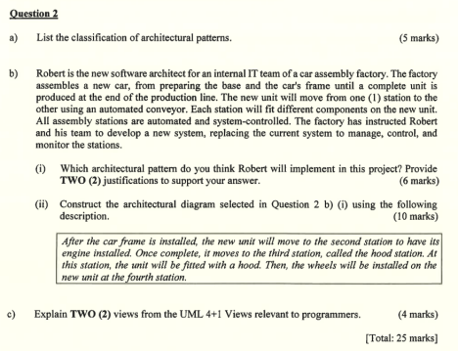
Additional Questions (Home Work)
a) A company is developing an online virtual banking system which provides banking services to the customers. The system is proposed to “virtually” represent a bank and providing almost 90% of bank services. The system requires an interaction between system components where the effects on each component is not significant. Components have their own functions and works either within the group of components with similar functions or different functions.
Page 2 of 3
BACS2073 Software Design and Architecture Tutorial 5
(i) Analyze and compare THREE (3) architecture patterns that are suitable for the above scenario. These architectures may appropriate either independently for the system or hybrid architectures. You may draw a table for the comparison purpose.
(ii) Based on the architecture patterns suggested from Question 1.(i), demonstrate and explain how the architecture of the online virtual banking is. You are required to draw a diagram to demonstrate the architecture with the pattern you have selected. In your diagram, you are required to include the examples of components that lay under different parts of the architecture pattern. You can apply more than one pattern for the design.
Page 3 of 3

